# **Section 002R**

**Question:**

The formula for finding distance covered by a vehicle is given below:

$$d=v_{i}t+\frac{1}{2}at^{2}$$

**d** is the distance covered by the car

**vi** is the initial velocity

**t** is the time taken by the vehicle

**a** is the acceleration

Suppose if the car has an initial velocity of 0, but it travels for 32.8 seconds with an acceleration of 3.2 m/s2, then what would be the distance travelled by the car?

**Output:**



# **Section 006R**

**Question:**

Newton’s law of gravitation can be written as:

$$F=G\frac{m_{1}m_{2}}{r^{2}}, G=6.67×{10}^{-11}$$

**F** is the attractive force between two masses

**m1** and **m2**are the two masses

**G** is a gravitational constant, which means it remains the same no matter what the masses are

**r** is the distance between the masses

Suppose that two objects m1 and m2 are 60 meters apart. m1 has a mass of 300000000 kgs and m2 has a mass of 189999999 kgs. What would be the gravitational attractive force between the masses?

**Output:**

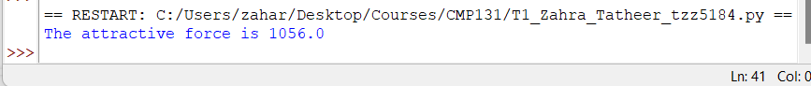

**Rubric for both:**

Correct filename -- 3.5 pts (no partial pts)

Format: "T1_Lastname_Firstname_loginId.py"

Example: "T1_Zahra_Tatheer_5184.py")

Comments as given in sample file -- 5 pts (1 pts for each comment)

Additionally, please make sure to have comments section in the beginning of your python file containing the following items:

Full Name:

ID:

Date:

Filename:

Purpose:

Variables used -- 10pts (2 pts for each variable)

Correct output as shown – 7.5 pts (no partial pts)

Total=25